Dissection Instructions
1. Place the frog in the dissecting pan ventral side up.
2. Use scissors to lift the abdominal muscles away from the body cavity. Cut along the midline of the body from the pelvic to the pectoral girdle.
3. Make transverse (horizontal) cuts near the arms and legs.
4. Lift the flaps of the body wall and pin back.
*If your specimen is a female, the body may be filled with eggs and an enlarged ovary. You may need to remove these eggs to view the organs.
Locate each of the organs. Check the box to indicate that you found the organs.
Digestive, Circulatory and Respiratory Systems

Fat Bodies --Spaghetti shaped structures that have a bright orange or yellow color, if you have a particularly fat frog, these fat bodies may need to be removed to see the other structures.
Peritoneum A spider web like membrane that covers many of the organs, you may have to carefully pick it off to get a clear view
Liver--The largest structure of the body cavity. This brown colored organ is composed of three parts, or lobes. The right lobe, the left anterior lobe, and the left posterior lobe. The liver is not primarily an organ of digestion; it does secrete a digestive juice called bile. Bile is needed for the proper digestion of fats. Bile is emptied into the gall bladder which then empties into the duodenum.
Heart - at the top of the liver, the heart is a triangular structure. The left and right atrium can be found at the top of the heart. A single ventricle located at the bottom of the heart. The large vessel that extends out from the heart is the conus arteriosis which supplies blood to the body.
Lungs - Locate the lungs by looking underneath and behind the heart and liver. They are two spongy organs. Lungs attach to the trachea via tubes called bronchi.
Gall bladder--Lift the lobes of the liver, there will be a small green sac under the liver. This is the gall bladder, which stores bile. (Hint: it kind of looks like a booger.) The gall bladder stores bile and then releases it into the duodenum via the bile duct. The bile duct may be too small to see.
Stomach--Curving from underneath the liver is the stomach. The stomach is the first major site of chemical digestion. Frogs swallow their meals whole. Follow the stomach to where it turns into the small intestine. The pyloric sphincter valve regulates the exit of food from the stomach
Pancreas – This glandular organ is located within the curve of the stomach. On preserved frogs it may not be easy to find, as the gland breaks down. It secretes insulin, which is needed for the proper breakdown of sugar.
Small Intestine--Leading from the stomach. The first straight portion of the small intestine is called the duodenum, the curled portion is the ileum. A membrane called the mesentery holds the ileum together. Note the blood vessels running through the mesentery; they will carry absorbed nutrients away from the intestine. Absorption of digested nutrients occurs in the small intestine.
Large Intestine--As you follow the small intestine down, it will widen into the large intestine. The large intestine is also known as the cloaca in the frog. The cloaca is the last stop before wastes, sperm, or urine exit the frog's body. (The word "cloaca" means sewer.) Locate the anus.
Spleen--Return to the folds of the mesentery, this dark red spherical object serves as a holding area for blood, where harmful particles can be filtered out for the immune system.
Esophagus--Return to the stomach and follow it upward, where it gets smaller is the beginning of the esophagus. The esophagus is the tube that leads from the frog’s mouth to the stomach. Open the frog’s mouth and find the esophagus, poke your probe into it and see where it leads.
STOP! If you have not located each of the organs above, do not continue!
Removal of the Stomach & Intestine
Cut the stomach out of the frog and open it up. You may find what remains of the frog's last meal in there. Look at the texture of the stomach on the inside. Note the ridges on the walls of the stomach called rugae. Rugae help to break down food. What did you find in the stomach? _________________________________
Measuring the Small intestine: Remove the small intestine and stretch it out and measure it. Now measure your frog. Record the measurements below in centimeters.
Frog length: ______ cm Intestine length ______ cm Which is longer? _____
Removal of the Heart
Carefully cut out the heart from its position above the liver. The vessel on the front of the heart is the conus arteriosis, which sends blood to the body. On the back you can find the openings for the anterior and posterior vena cava, which return blood to the heart. How many chambers does the frog heart have? ___
Urogenital System-
The frog’s reproductive and excretory system is combined into one system called the urogenital system. You will need to know the structures for both the male and female frog,
Kidneys – flattened bean shaped organs located at the lower back of the frog, near the spine. They are often a dark color. The kidneys filter wastes from the blood. Often fat bodies are attached to the kidney.
Testes – in male frogs, these organs are located at the top of the kidneys, they are pale colored and round.
Oviducts – females do not have testes, though you may see a curly-q type structure around the outside of the kidney, these are the oviducts. Oviducts are where eggs are produced. Males can have structures that look similar, but serve no actual purpose. In males, they are called vestigial oviducts.
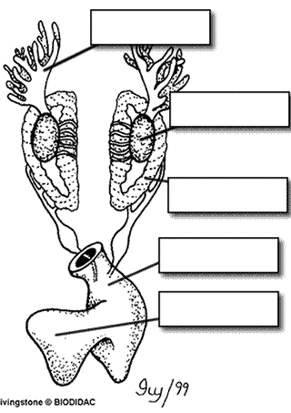
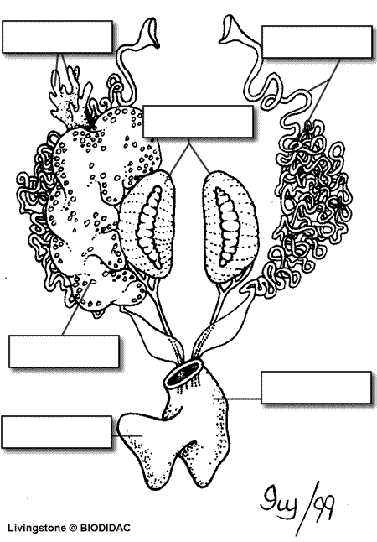
Bladder – An empty sac located at the lowest part of the body cavity. The bladder stores urine. Cloaca – mentioned again as part of the urogenital system – urine, sperm and eggs exit here.

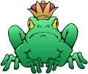
Post Lab Questions
1. The membrane holds the coils of the small intestine together: ________________________________
2. This organ is found under the liver, it stores bile: _____________________________________
3. Name the 3 lobes of the liver: ____________________, _______________________, _______________
4. The organ that is the first major site of chemical digestion: ___________________________
5. Eggs, sperm, urine and wastes all empty into this structure, the “sewer”: __________________________
6. The small intestine leads to the: ______________________________________
7. Blood leaves the heart through what large vessel? ________________________________________
8. Yellowish structures that serve as an energy reserve: ___________________________________
9. The first part of the small intestine (straight part): ______________________________________
10. This pair of organs filters wastes from the blood: _______________________________________
11. A spiderweb like membrane that covers the organs: _______________________________________
12. Regulates the exit of partially digested food from the stomach: __________________________________
13. The large intestine (cloaca) leads to the _____________________ (the opening to the outside )
14. Organ found within the mesentery that stores blood: __________________________________
15. The largest organ in the body cavity: ______________________________
16. Holding area for blood and also has a function in the immune system: ________________________
17. The esophagus leads to the _____________________, the glottis leads to the _______________________
18. Bile moves from the gall bladder to the duodenum through the ________________ duct.
19. The organ located near the stomach that makes insulin: _________________________
20. What structure is found above the kidneys but only in male frogs? ______________________
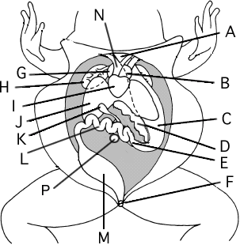
Label the Diagram
A. __________________________________
B. __________________________________
C. __________________________________
D. __________________________________
E. __________________________________
F. __________________________________
G. __________________________________
H. __________________________________
I. __________________________________
J. __________________________________
K. __________________________________
L. __________________________________
M. __________________________________
N. __________________________________
P. __________________________________

